**Assignment 1 – TokTik**

**Report**

OO Design

My design includes 8 classes, which all form the basis and functions of the TokTik application. The memory storage classes are BinarySearchTree, BinarySearchTreeTest, BinaryTreeNode, BTQueue, and BTQueueNode which when all put together make a Binary Search Tree that is able to store the many Accounts and Posts that are stored from a inputted file.The BinarySearchTree class is the main class where all other classes such as BinaryTreeNode, BTQueue and BTQueueNode are used to perform such storage functions. The other 3 classes that I used are the Posts, Account and TokTik which produce the objects that are taken from the file and allow them to be stored in the binary search tree as an account object. The Account class uses the Posts class to make a more easier and simpler version of an Account. The interface is run from the TokTik class which is where the binary search tree is filled with nodes in the form of Account objects. The classes interact with the construction of the BinarySearchTree which starts in the BinaryTreeNode class which does the construction of each node in the tree, next the BTQueueNode class interacts with the BinaryTreeNode class and forms the structure of the order methods of the tree, next we have the BTQueue class which orders the nodes of the tree, then most importantly we have the BinaryTree class which allows for the size, height and the multiple methods of ordering to be done to the nodes of the Binary Tree. For the TokTik application I used the InOrder queue method. Then comes our main class the BinarySearchTree which performs all the actions and methods that can be done on the tree such as find, insert and delete, which use all the BinaryTree classes mentioned before. In regards to the other classes the Posts class creates a post object which is used in the Accounts class to make the Posts link between an account and what posts they have created. Then finally the TokTik class which interacts with both the Accounts and Posts class to create Account objects and flood the Binary Tree with objects for its nodes.

Test Values

**Choice 1**

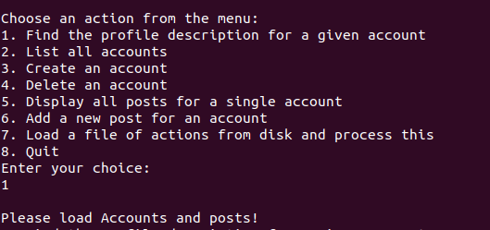

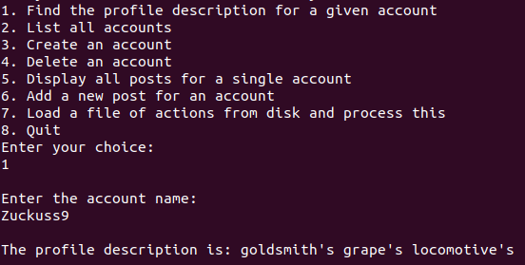

**Choice 2**

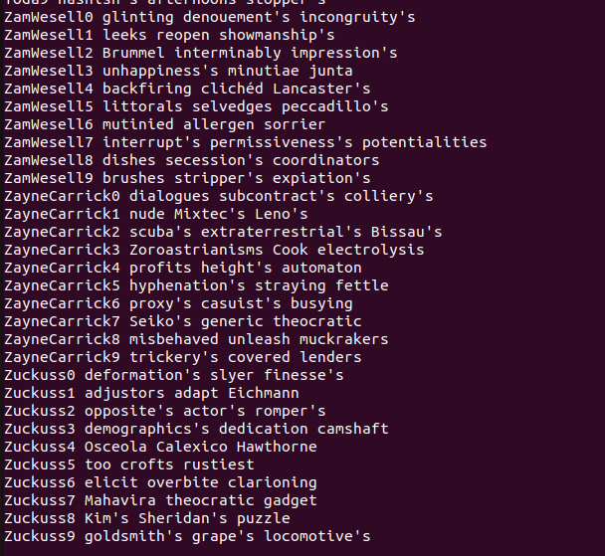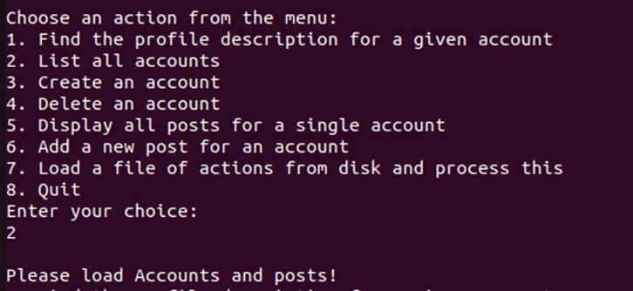

Values are continued…

**Choice 3**

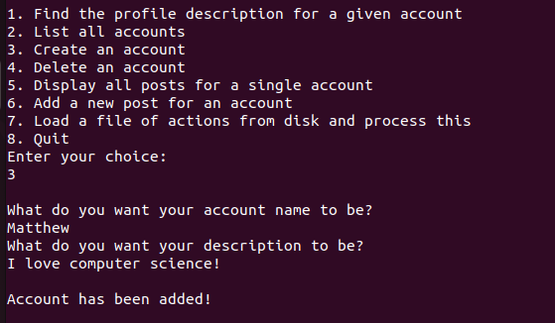

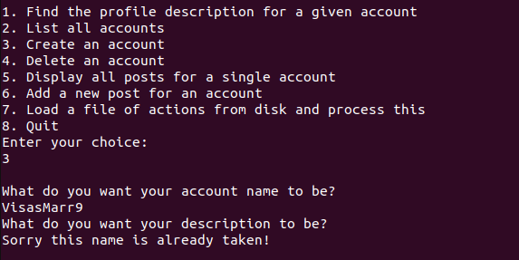

**Choice 4**

**Choice 5**

**Choice 6**

**Choice 7**

Output continues…

**Choice 8**

Creativity

For creativity I only added a closing TokTik logo when the user decides to exit the system

Statistics

